Moon Diary
A lunar cycle is 28 days. Draw the shape of the moon each evening for 28 days (weather permitting)
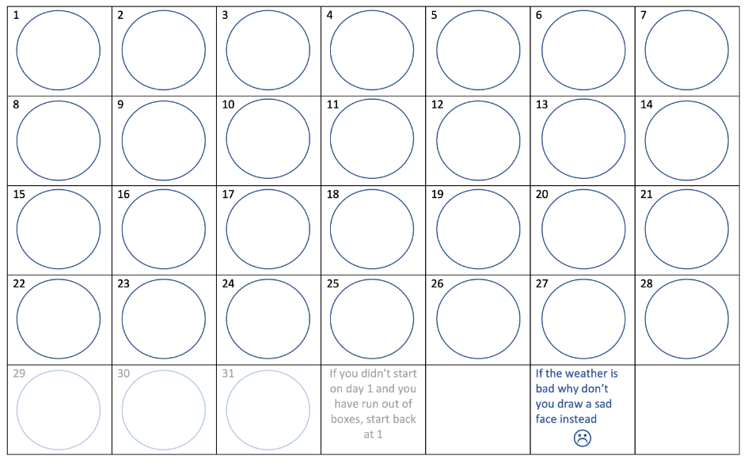

Moon Phases
The rotation of the Moon around the Earth makes the Moon appear as if it is changing shape in the sky. These shapes are called "phases" of the Moon. The phase you see when you look at the moon depends on its location between the Earth and the Sun. Standing on Earth, we see the bright part of the Moon's surface. The Moon doesn't create any light itself; it just reflects the light of the Sun. The phases always follow one another in the same order.

