Moon

Moon Phases

The revolution of the Moon around the Earth makes the Moon appear as if it is changing shape in the sky. This is caused by the different angles from which we see the bright part of the Moon's surface. These are called "***phases***" of the Moon. The phase you see when you look at the moon depends on its location in relationship to the Sun and Earth. The Moon doesn't create any light itself; it just reflects the light of the Sun. The fraction of the moon that appears illuminated changes since the moon is orbiting the earth. The time it takes the Moon to complete one orbit around the earth (with respect to the sun) is also the amount of time it takes to complete one cycle of moon phases. This period, known as the ***synodic month***, is about 29.5 days. The phases always follow one another in the same order.

Define Moon Phases

**New moon** – moon is between the Earth and Sun so it is not visible in the night sky

**Waxing Crescent**

***Waxing*** - "growing" or expanding in illumination

***Crescent*** - the moon is *less* than half illuminated

**First quarter moon**; half of the moon is visible

***Waxing Gibbous***

***Waxing*** - "growing" or expanding in illumination

***Gibbous****-* the moon is *more* than half illuminated

**Full moon** – about 2 weeks after a new moon

***Waning Gibbous***

***Waning*** *-* "shrinking" or decreasing in illumination

***Gibbous*** *-* the moon is *more* than half illuminated

**Third quarter moon**; half of the moon is visible

**Waning Crescent**

***Waning*** *-* "shrinking" or decreasing in illumination

***Crescent*** - the moon is *less* than half illuminated

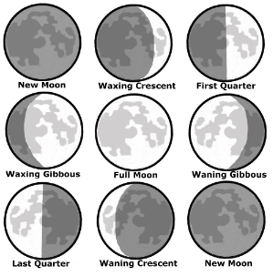**New moon** – Cycle begins again

**Blue moon** - the second full moon in a calendar month