Games of the Past

***Games Around the World***

*Kim’s Game* (England)

**Teacher’s introduction to the material:**

Children all over the world play games. Here are some for you to try. Girl Scouts and Girl Guides all over the world play this game. You and your friends can have fun playing it, too!

**Materials**:

At least 10 small items

A scarf or piece of cloth

**Instructions:**

1. Put 10 things on a table. Be sure you can cover all of them with a scarf or piece of cloth.

2. Show the players the 10 items for one minute. Then cover them.

3. Ask the players to list the 10 items.

Red Light, Green Light

(United States)

**Instructions:**

1. Choose someone to be “it.” The person who is “it” stands at one end of the playing field,

far away from all the other players.

2. The other players line up along the starting line at the opposite end of the field.

3 “It” turns her back and yells “green light.” The players may now run toward “it.”

4. When “it” yells “red light” and turns around, everyone must stop running and freeze.

If “it” catches anyone moving, that person has to go back to the starting line.

5. The game continues until “it” is touched during “green light”.

6. That person that touches “it” becomes “it” and the game starts again.

*Sheep and Hyena*

(Sudan)

**Teacher’s introduction to the material:**

See if you can keep the sheep away from the hungry hyena! Get at least 10 people to play.

**Instructions:**

1. Players join hands and form a tight circle.

2. The hyena stays outside the circle. The sheep stays inside the circle.

3. The players in the circle have to try to keep the hyena from breaking through the circle to

get to the sheep. The game ends when the hyena gets the sheep or gets too tired to go after

the sheep anymore.

4. Two other people become the sheep and hyena.

*Hawk and Hens*

(Zimbabwe)

**Teacher’s introduction to the material:**

This is a great chasing game for times when you have lots of energy and want to run. You will need at least four people and two safety zones.

**Instructions:**

1. One person is the hawk, and all the other players are hens.

2. The hawk stands between the safety zones and tries to catch the hens as they run back and

forth from one safety zone to the other.

3. When a hen is caught, she sits on the side and watches the game.

4. The last hen to be caught by the hawk becomes the next hawk.

Jan-Ken-Pon

(Japan)

**Teacher’s introduction to the material:**

This is a game for 2 players.

**Instructions:**

1. Two players face each other with their hands behind them.

2. Together they say ”Jan-Ken-Pon.” On “pon,” both bring a hand forward to stand for a stone

(a fist), paper (flat hand), or scissors (V-shape with the index finger and middle finger).

3. Stone beats scissors, because it can break them. Scissors beat paper because they can cit it,

and paper beats stone because paper can wrap up the stone.

4. A player get a point each time her hand beats the other’s. The first player who gets seven

points wins.

* 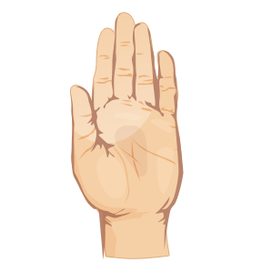 *

**Paper Rock Scissors**