Games of the Past
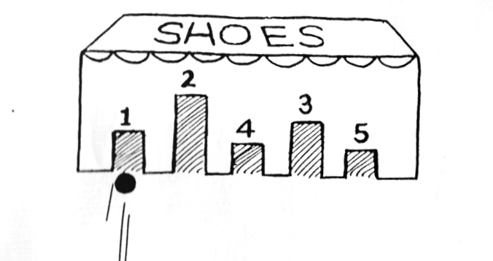
Marble Shoebox Game
Material List: Small to medium box
Marbles
Score card

Objectives: Learn the rules of the game.
Learn to keep an accurate record of their own score.

Teacher’s introduction to the activity:
Prepare a box with doors 1-inch wide and 2-5 inches high. Write a number above each door. Mark the starting line. The students will roll 10 marbles from the starting line aiming for a door. They will record the door numbers they roll a marble through. Decide
if the first person to reach 100 wins or the player with the highest score after 10 marbles wins.

Instruction:
Students will shoot for the doors and will score points according to the number above the door. After 10 marbles have been played students calculate their scores.

Marble Game
Name_____________________
Marble Played # Above Door Total
Marble 1
Marble2
Marble 3
Marble 4
Marble 5
Marble 6
Marble 7
Marble 8
Marble 9
Marble 10

