Games of the Past

Turtle Race

**Materials:**

Wooded turtles threaded onto string attached at one end

Game Instructions

**Objectives:**

1. Take turns and to wait patiently while others are racing.
2. Learn that many different motions are required to go from place to place.

**Teacher’s introduction to the activity:**

Attach one end of 15 to 30 feet of twisted cord to a peg driven in the ground, a chair or table brace, or other support the same height as the holes in the turtles. The race begins with the turtles at the far end of the cord and leaning slightly toward the “jockeys.” On a signal, boys alternately tighten and relax the cords so that the turtles move toward them in wormlike fashion.

**Instructions:** To Begin the Race:

1. Hold the cords taut with turtles leaning slightly toward the attached end.
2. On the signal “Go,” race the turtles toward the attached end.
3. Race them by tightening and relaxing the cords so that the turtles move along the string.
4. The first turtle to touch the attached end wins.

**Variations:** Divide the children into 2 groups with the same number of students on each team. The winner is the group that finishes first.

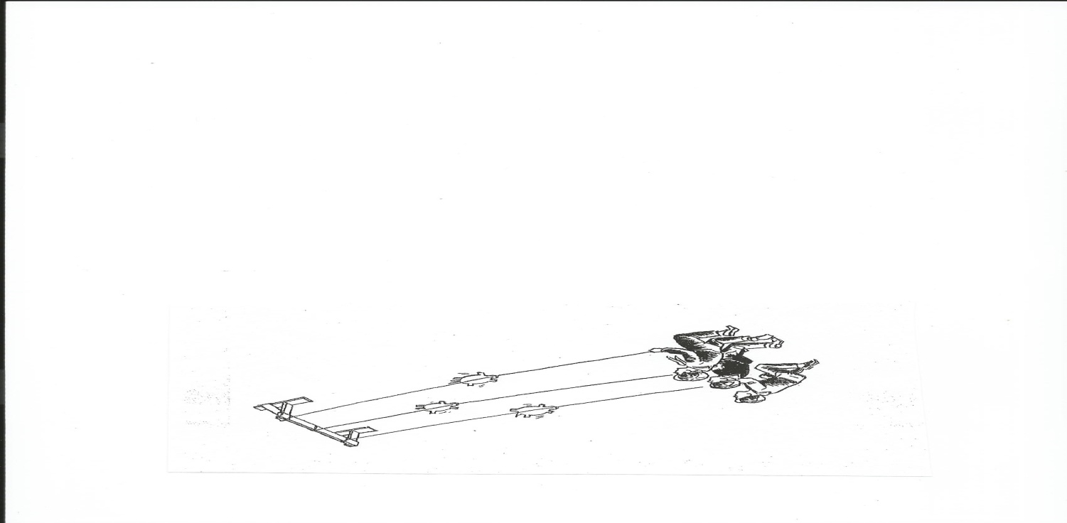

Enlarge the turtle pattern to make the turtles about 8 inches tall. Cut from 1 ⁄4- or 3 ⁄8-inch plywood or heavy cardboard. Make the hole in the turtle slightly larger than the diameter of the cord you will use.