Games of the Past

Marbles
Materials: 13 marbles & 1 shooter
Chalk or spade to make 3-foot circle diagram

Classroom Time: 1 class period

Teacher’s introduction to the activity:
Marbles – an ancient game played with small balls or nuts. Marbles have been found made glass, stone, clay, and wood. A cat's eye marble is a type of glass marble that has a clear base with a colored core that resembles the eye of a cat. Cat's eye marbles were first made in Japan in the 1950s and became popular in the United States in the 1960s. A "taw" or "shooter" is a larger marble used to shoot with, and "ducks" are marbles to be shot at.

Objectives:
1. The student will learn the rules of Marbles.
2. The student will play marbles observing the rules.
3. The student will observe the geometric angles when one object hits another.
4. The student will observe the power necessary to move objects a given distance.
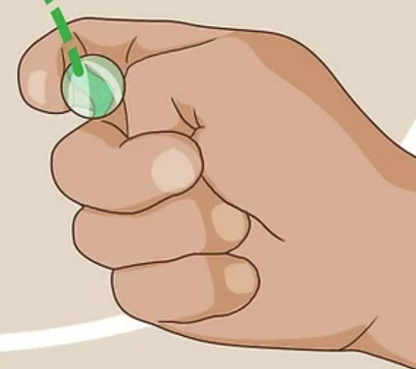
Instruction:
To shoot your marble correctly, fold your thumb, pinkie, and ring finger into your palm. Roll your pointer finger around the marble, holding it against your thumb knuckle. When you're ready to shoot, flick your thumb out.

Your objective is to knock marbles out of the ring. Collect any marbles you knocked out of the circle during your turn.

If the first player knocks a marble out of the circle, they are awarded another turn. If they don’t knock a marble out, the turn goes to the next player.

Once the circle is empty of small marbles, the game is over. The winner is the player who bumped out the most marbles.

Lag Line

Pitch Line

