Arbor Day North Dakota

First Friday in May

North Dakota State Tree - American Elm - *Ulmus americana*

Leaf: Alternate, 3 to 6 inches long, 1 to 3 inches wide

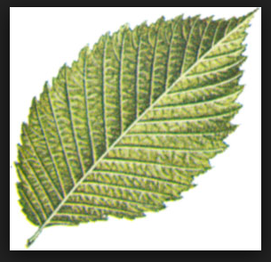

Flower: Appears March to May before leaf buds open

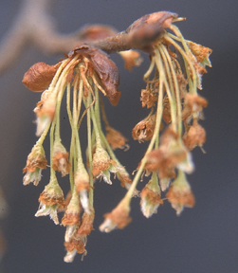

Fruit: appears April to May.

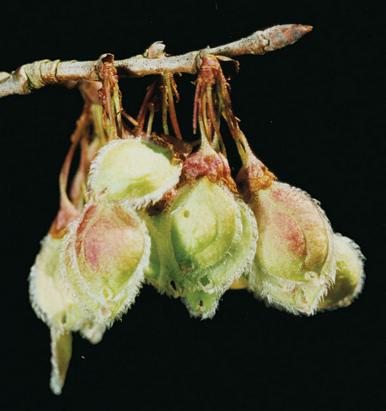

Twig: Slender, reddish-brown

Bark: Dark, ashy-gray, flat-topped ridges separated by diamond-shaped fissures

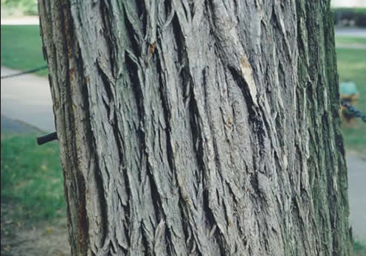

Form: In the open, the trunk is usually divided into several large, ascending and arching limbs, ending in a maze of graceful drooping branchlets.

