Geospatial Education

Geoscientists Study the Planet Earth

Starting from the ground up.

Geologists work to understand the geosphere or the solid part of the planet Earth.

Geographers work to understand the biosphere. The biosphere is where there is life on the planet Earth.

Atmospheric Scientists work to understand both the atmosphere and the hydrosphere. The atmosphere is the layer of gases around the Earth held in place by gravity. The hydrosphere is where the water cycle takes place on the planet Earth.

Earth Scientists use field studies and observations to learn more about the planet Earth. A field study takes them outside to explore a designated location or a particular process such as a tornado. They write down their observations in a science notebook called a field notebook.

***Go outside and be a geoscientist.*** Write your observations in the field notebook. Make more pages for the things you want to study.

Geology

Erosion takes place when materials in the landscape are moved from one location to another. Rainstorms move dirt, pebbles, and rocks from the land to the river. Rivers deposit these materials downstream. Rivers erode or remove the land on the banks of the river and create new land at bends in the river.

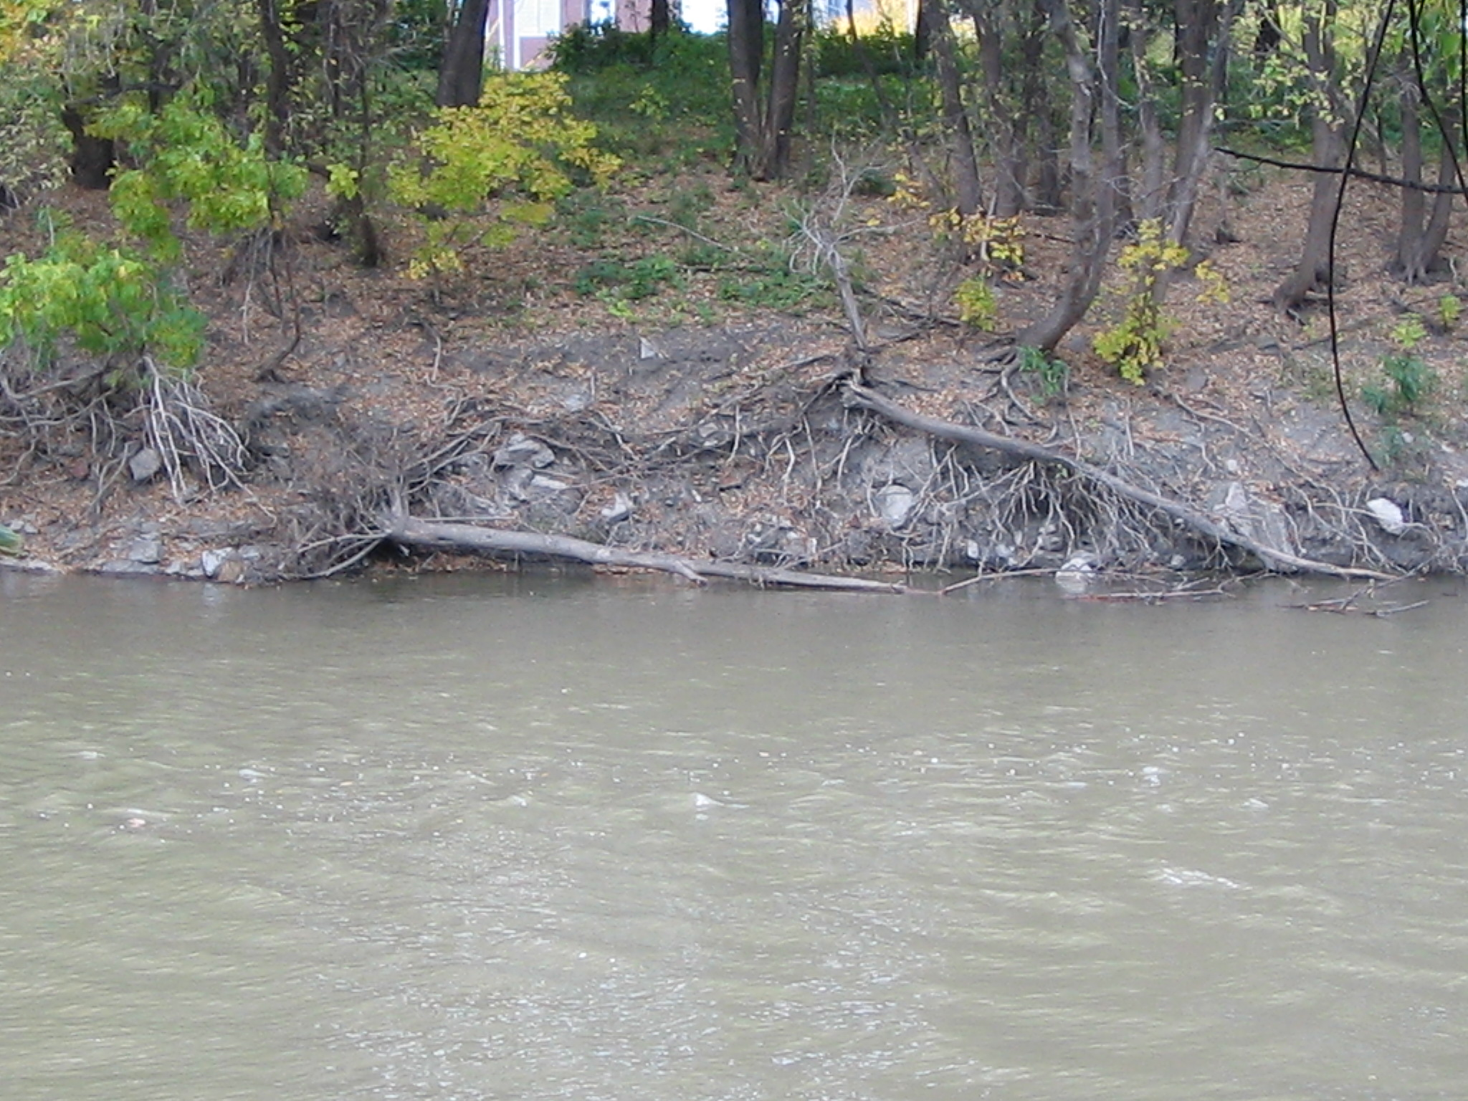

Can you see erosion? What caused the erosion?

Geography

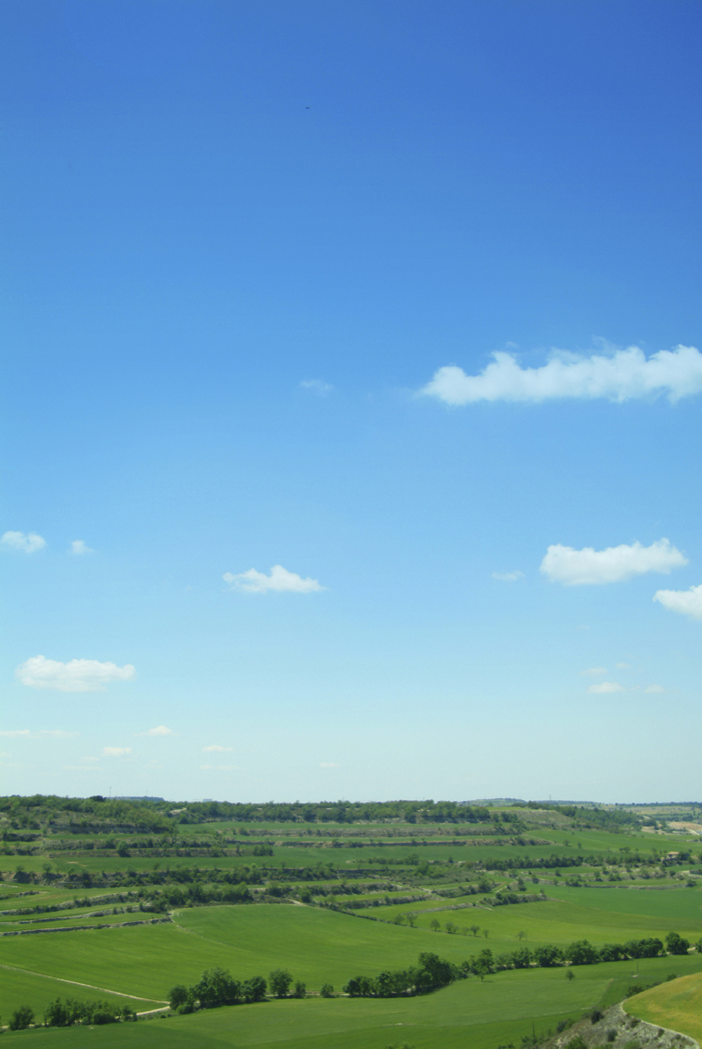

Physical geographers use the term **biosphere** to describe our living world. The biosphere extends to the upper areas of the [atmosphere](http://www.geography4kids.com/files/atm_intro.html) where birds and insects can be found. It reaches deep into the ground; a dark cave where bats and other organisms live. It extends to the bottom of the [ocean](http://www.geography4kids.com/files/water_biomeaqua.html) where organisms live without light. The biosphere includes all the places on the planet Earth where there is life (of any kind).

**What do you see in the biosphere?**

Atmospheric Science

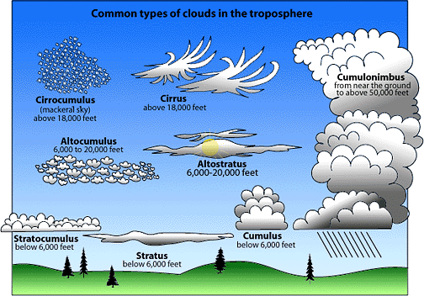

**Cloud** - A visible collection of very fine water droplets or ice crystals suspended in the atmosphere at altitudes from just above the ground to several miles above sea level.

What Clouds Do You See?

Geocaching

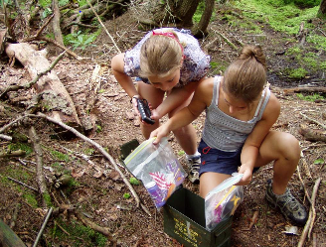

The word Geocaching broken out is GEO for geography, and CACHING for the process of hiding a cache. A cache in computer terms is information usually stored in memory to make it faster to retrieve, but the term is also used in hiking/camping as a hiding place for concealing and preserving provisions.

In its simplest form a cache can be just a logbook and nothing else. The logbook contains information from the founder of the cache and notes from the cache's visitors. A logbook might contain information about nearby attractions, coordinates to other caches, and even jokes written by visitors. If you get some information from a logbook you should give some back. At the very least you can leave the date and time you visited the cache.

GPS is an acronym for Global Positioning System. The Global Positioning System has 3 segments. The satellites are the space segment. The control segment is made up of the ground antenna control stations. The individual GPS units make up the user segment.

When using a handheld GPS unit, you can 1) enter known waypoints in advance so that the GPS unit guides you from one waypoint to the next; 2) walk a trail and have the GPS unit keep track of waypoints along the way so you can print a map later or 3) use a GPS unit more like a compass to find waypoints. Using the GPS unit like a compass is a great way to get comfortable with latitude and longitude.

Waypoint example N 47°55’30” W 097º1’58”. It is read North 47 degrees 55 minutes and 30 seconds West 97 degrees 1 minute and 58 seconds. Some GPS units give degrees and minutes with the seconds as a decimal N 47°55.030’. Compare the positional reading on the GPS unit with the waypoint you want to find:

N 47°55.030’ W 097º01.058 your location

N 47°55.046’ W 097º01.050 waypoint you are looking for

In this case you want to increase the north position and decrease the west position, so you will walk northeast.

The GPS unit shows you how many satellites it is using to find your location. Remember that it takes a minimum of 4 satellites to provide an accurate location. As with any technology you should always carry a backup technology. If you were going on a hiking trip in an unfamiliar area you should bring a trail map, a topographic map and compass with you so that you are not completely dependent on the GPS unit.

Leave no Trace

*Plan Ahead and Prepare*

* Use a map and compass to eliminate the use of marking paint, rock cairns or flagging.

*Travel and Camp on Durable Surfaces*

* Durable surfaces include established trails and campsites, rock, gravel, dry grasses or snow.
* Concentrate use on existing trails and campsites.
* Walk single file in the middle of the trail, even when wet or muddy.

*Dispose of Waste Properly*

* Pack it in, pack it out. Inspect your campsite and rest areas for trash or spilled foods. Pack out all trash, leftover food, and litter.

*Leave What You Find*

* Preserve the past: examine, but do not touch, cultural or historic structures and artifacts.
* Leave rocks, plants and other natural objects as you find them.

*Respect Wildlife*

* Observe wildlife from a distance. Do not follow or approach them.
* Never feed animals. Feeding wildlife damages their health, alters natural behaviors, and exposes them to predators and other dangers.

*Be Considerate of Other Visitors*

* Respect other visitors and protect the quality of their experience.
* Be courteous. Yield to other users on the trail.
* Let nature's sounds prevail. Avoid loud voices and noises.

While hiking did you see infractions of the

Leave no Trace etiquette?