Bumble Bee Watch (https://www.bumblebeewatch.org/) is a collaborative effort to track and conserve North America’s bumble bees. This community science project allows for individuals to:
- Upload photos of bumble bees to start a virtual bumble bee collection;
- Identify the bumble bees in your photos and have your identifications verified by experts;
- Help researchers determine the status and conservation needs of bumble bees;
- Help locate rare or endangered populations of bumble bees;
- Learn about bumble bees, their ecology, and ongoing conservation efforts; and
- Connect with other community scientists.

How can you participate?
We need your help! Because these animals are widely distributed the best way to keep track of them is with a group of volunteers across the country equipped with cameras. Participating in Bumble Bee Watch is simple and you can get started now by creating an account via the “sign in” tab at the top of the page. Once you have an account, go out and check your garden, in parks, or any other natural areas you frequent for bumble bees. Be sure to snap a photo, sign in and submit your data via our Bumble Bee Sightings form. Have fun while learning more about bumble bees and the vital role they play in our environment!
Other ways you can help:
- Create habitat! You can find more information about how to create bumble bee habitat at www.xerces.org/bumblebees.
- Support local and organic agriculture. Many pesticides are harmful to bumblebee colonies and many vegetable and fruit plants provide great food sources for bees.
- Spread the word! Many people are afraid of bumble bees and other insects. Let your friends and family know how important they are and encourage them to take photos too!
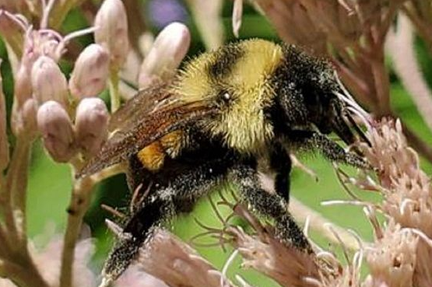
Wisconsin Department of Natural Resources

