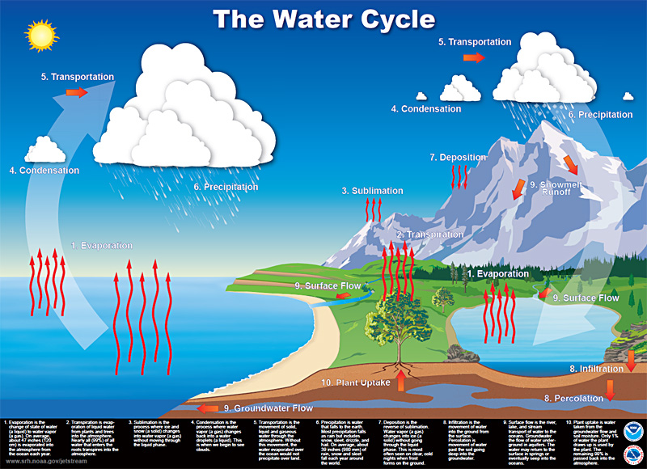

Water Cycle

**Accumulation** is the gathering of water when it flows from higher ground down into the rivers, oceans, lakes, and puddles.

**Condensation** is the process where water vapor becomes water droplets (a liquid).

**Deposition** is the reverse of sublimation. Water vapor (a gas) changes into ice (a solid) without going through the liquid phase.

**Evaporation** is the change of state of water (a liquid) to water vapor (a gas).

**Evapotranspiration** – is the collective term for evaporation and transpiration in the water cycle.

**Groundwater** is water held underground in the soil or in the pores and crevices of rock.

**Infiltration** is the movement of water from the surface into the ground.

**Percolation** is movement of water through soil deep into the groundwater.

**Plant uptake** is water taken from the soil by plants.

**Precipitation** is water that falls to the earth.

**Respiration** is the process in which animals release water vapor when breathing.

**Runoff** is the draining away of water from the surface of the land.

**Sublimation** is the process where ice and snow (a solid) changes into water vapor (a gas) without moving through the liquid phase.

**Surface flow** is the river, lake, and stream transport of water to the oceans.

**Transpiration** is evaporation of liquid water from plants and trees into the atmosphere.

**Transportation** is the movement of solid, liquid and gaseous water through the atmosphere.